NIT-200

4-jaw through-hole power chuck (adapter excluded)
- All sliding surfaces are hardened and ground for accurate actual running and long service repeatability. Lubrication nipple in each master jaw.
- Master jaw : 1.5mm x 60° serration.
- Mounting : Adaptor mounting to fit with DIN, ISO, BS, ASA B5.9 type A spindles.
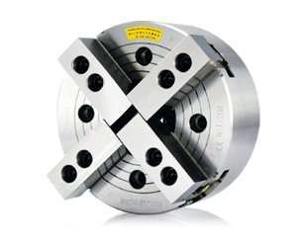
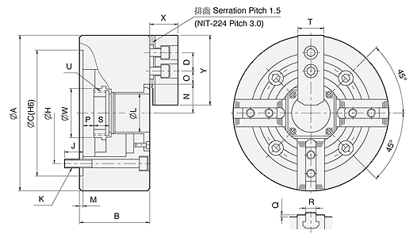
UNIT : mm
SPEC  Model | Through  -Hole  (mm) | Plunger  Stroke  (mm) | Jaw  Stroke  (In Dia.)  (mm) | Max.  Pull  Force  (kgf) | Max.  Gripping  Force  (kgf) | Max.  Operating  Pressure  (kgf / cm²) | Max.  Speed  (r.p.m.) | Weight  (kg) | Moment  Of Inertia  I  (kg‧m² ) | Matching  Cylinder | Matching  Hard Jaw | Matching  Soft Jaw | Gripping  O.D. Range  (mm)
NIT-206 | Ø45 | 12 | 5.5 | 2243 | 5812 | 28.5 | 4500 | 13.7 | 0.058 | M1246 | HJ06 | HC06 | Ø15-Ø169
NIT-208 | Ø52 | 16 | 7.4 | 3558 | 9075 | 26.5 | 3600 | 24 | 0.177 | M1552 | HJ08 | HC08 | Ø20-Ø210
NIT-210 | Ø75 | 19 | 8.8 | 4385 | 11319 | 27.5 | 3200 | 36 | 0.324 | M1875 | HJ10 | HC10 | Ø25-Ø254
NIT-212 | Ø91 | 23 | 10.6 | 5812 | 14990 | 27.5 | 2700 | 58.5 | 0.763 | M2091 | HJ12 | HC12 | Ø30-Ø304
NIT-215 | Ø117.5 | 23 | 10.6 | 7240 | 18355 | 23.5 | 1900 | 114 | 2.331 | M2511 | HJ15 | HC15 | Ø50-Ø381
NIT-218 | Ø117.5 | 23 | 10.6 | 7240 | 18355 | 23.5 | 1500 | 140 | 3.798 | M2511 | HJ15 | HC15 | Ø50-Ø450
NIT-224 | Ø205 | 26 | 12 | 9177 | 23861 | 26.5 | 1000 | 284 | 15.2 | ML3320 | HJ24-1 | HC24-1 | Ø150-Ø610

DIM  Model | A | B | C  (H6) | D | H | J | K | L | M | N  max. | O  max. | O  min. | P  max. | P  min. | Q | R | S | T | U  max. | W | X | Y
NIT-206 | 169 | 81 | 140 | 20 | 104.78 | 16 | 4-M10x80 | 45 | 5 | 32 | 22.75 | 9.25 | 11 | -1 | 2 | 12 | 19 | 31 | M55x2 | 60 | 37 | 73
NIT-208 | 210 | 91 | 170 | 25 | 133.35 | 20 | 4-M12x90 | 52 | 5 | 38.7 | 29.75 | 11.75 | 14.5 | -1.5 | 2 | 14 | 20.5 | 35 | M60x2 | 66 | 38 | 95
NIT-210 | 254 | 100 | 220 | 30 | 171.45 | 22 | 4-M16x100 | 75 | 5 | 51 | 33.75 | 14.25 | 8.5 | -10.5 | 2 | 16 | 25 | 40 | M85x2 | 94 | 43 | 110
NIT-212 | 304 | 110 | 220 | 30 | 171.45 | 23 | 4-M16x110 | 91 | 6 | 61.3 | 45.75 | 15.75 | 8 | -15 | 2 | 21 | 28 | 50 | M100x2 | 108 | 51 | 130
NIT-215 | 381 | 133 | 300 | 43 | 235 | 35 | 4-M20x135 | 117.5 | 6 | 82 | 45.25 | 15.25 | 7 | -16 | 5 | 22 | 43 | 62 | M130x2 | 139 | 66 | 165
NIT-218 | 450 | 133 | 300 | 43 | 235 | 35 | 4-M20x135 | 117.5 | 6 | 82 | 79.75 | 15.25 | 7 | -16 | 5 | 22 | 43 | 62 | M130x2 | 139 | 66 | 165
NIT-224 | 610 | 147 | 520 | 60 | 463.6 | 35 | 8-M24x150 | 205 | 6 | 139.9 | 87.5 | 24.5 | 16 | -10 | 5 | 25 | 38 | 64 | M215x3 | 230 | 73 | 180

